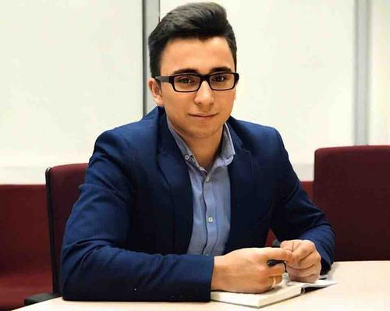 |  |  | Sharma Denis Devinderovich  Man, 20 years old, born February 27, 1999  +7 (967) 0227774  Dpolo001@mail.ru  Residence: Moscow, metro Dmitrovskaya  Citizenship: Russia, Canada, have a work permit: Russia  Not ready to move, ready for rare business trips
Desired position and salary
Administrative assistant  Administrative staff  • Personal assistant  • Office work  • Reception  Employment: Full-time  Schedule: full day  Desired travel time to work: doesn't matter |  |  |  |  | 50 000  руб.
Work experience —2 years 7 months
March 2019 –  June 2019  4 months |  |  |  | American Chamber of Commerce in Russia  Москва, www.amcham.ru  Office administrator  Support for office employees, in the performance of personal instructions, support in the CRM system, adding and updating data. Support in the organization of events, assistance in the registration of participants, site organization.  Reception and processing of telephone calls and correspondence, organization of conference call  Assistance in holding meetings (ordering passes, preparing meeting rooms, supporting negotiations)  Document management in accordance with corporate standards of the company  Organization of postal items  Organization of business trips of employees, booking air and train tickets  Office life support (stationery order)  Execution of management assignments
September 2017 - February 2019  1 year 6 months |  |  |  | International Youth Diplomatic Club  Москва, amicability.org/  The chairman  Carrying out active work with youth, holding events, conferences, creating various projects. Support for managers, coordination of project work, monitoring the work of groups in various areas, solving various cases and finding a total solution.  receiving and distribution of incoming calls  life organization of various directions  Run social networks  participation in organizing events for employees and clients, as well as joint events with other youth organizations.
December 2016 - May 2018  1 year 6 months |  |  |  | ЕАСПП  Москва  President's advisor  incoming / outgoing calls, conference calls, video conferencing  receiving / sending correspondence by mail, express delivery  processing of incoming and outgoing correspondence, business correspondence  meeting, reception and necessary services for guests, customers and partners  booking and buying air, railway and other types of tickets for employees and partners of the company  reservation and accommodation for employees and partners of the company  office support  execution of personal instructions of the head  preparation of documents, materials, information necessary for the office and solving current problems  assistance to employees and partners of the company in solving problems arising during the work.
January 2018 - March 2018  3 months |  |  |  | State Duma of the Russian Federation  Москва, www.duma.gov.ru/  Deputy assistant  Meeting and information support for guests  according to corporate etiquette,  maintaining a schedule of meeting rooms (organization of meetings),  maintenance of the register of incoming and outgoing letters  preparation of letters in accordance with the internal regulations for registration of correspondence,  Organization of external and internal meetings, maintaining protocols, familiarization with protocols, monitoring the implementation of decisions on protocols;  receiving and sending faxes (if necessary).
Education
Высшее
2020 |  |  | Russian State University for the Humanities, Moscow  International Relations, World Politics and International Business
2016 |  |  | School № 1236(Russia)  School
2014 |  |  | Morning Star Middle School(Canada)  School
2013 |  |  | Morning Star Middle School(Canada)  School
2010 |  |  | Morning Star Middle School (Canada)  School
key skills
Knowledge of  languages |  | Russian - Native  English – Native French – Beginner
Skills |  | Communication skills, Stress resistance, Punctuality, Teamwork, Desire to learn new Negotiating, Presentation skills, Conducting presentations, Literate speech, MS PowerPoint English language, Business communication Organizational skills Field events
Additional Information
Recommendations |  |  | International Diplomatic Club 'Amicability'  Dvoryanov Sergey Viktorovich (President)
About me |  |  | My personal qualities:  Well-developed organizational skills, a high level of responsibility and self-organization, the ability to work in multitasking mode and correctly prioritize, diplomacy, friendliness, sociability, diligence, stress-resistant, fluent English. French basic.

